CHAPTER 9: Energy transmission
Worksheet 9.1

Sound energy
Science Quest 9: pages 308–11
Student: Class:

Wavelength and frequency
1. The following diagram shows two vibrating tuning forks producing sound waves.
A | 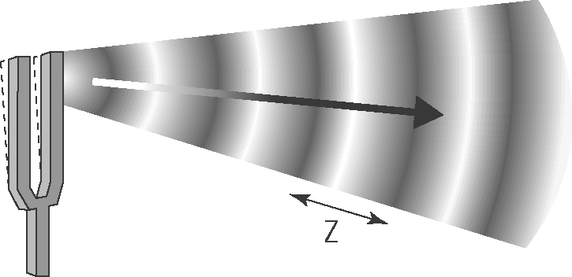 | (a) Identify the features of the wave labelled X, Y and Z.  X:  Y:  Z:  (b) Which sound wave has the lowest pitch?  Explain.
B | 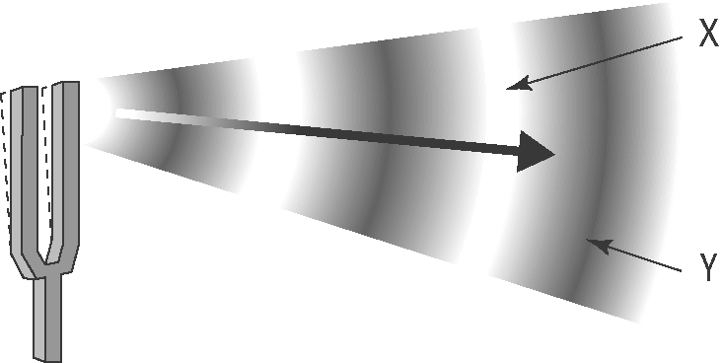

Speed of sound in water
2. The following graph shows how the speed of sound (in m/s) in water varies with temperature (in °C).
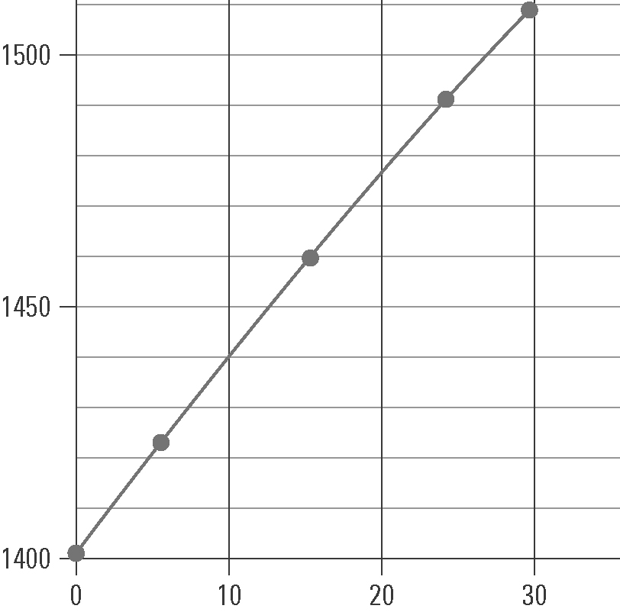 | (a) The labels and units on each axis are not shown. Insert these labels and units.  (b) Give the graph a title.  (c) Use the graph to determine the speed of sound in water at:  (i) 0 °C  (ii) 10 °C  (iii) 20 °C  (d) In air, the speed of sound at 0 °C is 331 m/s.  (i) How many times faster does sound move in water than air at that temperature? (Hint: Divide one speed by the other.)
(ii) Explain why sound moves faster in water than in air.

